Reg. No. - 51/BARAN/2008-09

ANNUAL REPORTFOR
THE YEAR
2021-22
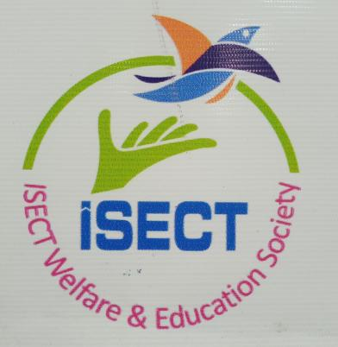

ISECT WELFARE AND EDUCATION SOCIETY-BARAN
Near Vishnu Vyayam Shala, Kumaharon Ka Mandir, Sabji Mandi Ki Tek-Baran, Rajasthan
Mail-baranisect@gmail.com Mob-96490777

ISECT WELFARE & EDUCATION SOCIETY
A Society registered under society act 1960

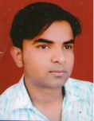FROM THE DESK OF CHAIRMAN

I believe in total complete utilization of the resources possessed by the great nation like India. Youth is also most important and crucial aspect to become world GURU. All the nations are looking towards India to supply Indian minds and legs to them. My dream is to skill youth as per their interest and make the compatible to today’s scenario

INTRODUCTION

Profile: “To whose inspiration, devotion and energy the inception of this group is due”
ISECT Welfare and Education Society, has been a proven leader in the field of vocational and skill education since 2008. It has been successful in providing government sponsored progamme , which aims to produce promoters of social transformation endowed with the spirit of service to mankind, through moral and academic excellence.
Mr. Sabir Ahmad founder of ISECT Welfare and Education Society, believe that each youth is special and has unique skill that we can nourish , with a view to perpetuate the name of a sustainable individual and the revolutionary son of the soil among the youth of future generations, He established ISECT Welfare and Education Society only 15 years before. In just a short span of time, the ISECT Welfare and Education Society has strongly emerged as one of the largest fast growing institution in Baran. His prime goal is for each youth to flourishin a happy, safe, positive environment.
ISECT Welfare and Education Society incorporated in the year of 2008 with the aim to educate, skill, spread awareness regarding social and educational transformation in the society. ISECT is a very reputed organization in its area of work. Demographically very challenging, deprived,marginalized and unemployed are of the district in Rajasthan. ISECT took up its operations in the area of digital literacy, skill development, nukkad campaigning for the betterment of the individual as well as society.

VISION AND MISSION

Vision :ISECT has been set up on the rock solid foundation of “HUNAR HAI TO KYA FIKAR HAI”. Every initiative, every effort in our institution focuses single-mindedly on this core value. So while the mind goes through the process of learning, it will automatically, continually and effortlessly imbibe them and give the individual, a self sustainable, skilled personality.

Mission: The mission of ISECT Welfare and Education Society is to provide awareness about government funded programs and appeal to all beneficiaries with different special skill sets. We combine traditional methods with adaptations and modifications to provide stimulating programs for beneficiaries. Our focus is to use our expetise to the fullest extent possible to enable them to enjoy improved life outcomes as productive members of society.

Organizational structure
TREASURER
Tanveer Ahmed
CHAIRMAN
Sabir Ahmed
SECRETARY
Siraj Ahmed

SOCIETY MMEMBERS

ACCOUNTS AND FINANCE
Dilkhush Vaishnav
NATIONAL HEAD
SalimKhan

STATE HEADS
Himmat Ram
CENTER HEADS
IT Head
Moh. Ashif
Training Head
Haider Ali
Social Welfare activities
Mobilisation Head
IT Executive
Trainers
Mobilizers
Other Supportive Staff at Centers

AREA OF OPERATIONS

State Government Funded Shemes

ISECT
Central Government Funded Shemes

Paid Skill Development Shemes

Social Awareness Programme

ISECT is empanelled with Governemt of Rajasthan through Rajasthan Skill and Development Corporation (RSLDC), Rajasthan Knowledge Corporation Limited (RKCL) and running various programme of the state in the area of skill development,digital literacy and women empowerment.
ISECT is affiliated with state mission and Ministry of Rural Development (MoRD) through flagship scheme namely DDUGKY where it works exclusively for the benefit of school/college dropouts, unemployed,poor and deprived youths.
So Far ISECT has educated and skilled thousands of beneficiaries directly or indirectly. The way, miles to go further.
ISECT is empanelled with State, Central and local bodies with many schemes mentioned below;-
- Deen Dayal Upadhyay Gramin Kaushalya Yojana (DDU-GKY).
- Regular Skill Training Programme (RSTP).
- Swarojgar Aadharit Kaushal Shiksha Mahaabhiyan (SAKSHM).
- Rojgar Aadharit Jan Kaushal Vikas Karyakram (RAJKViK).
- Rajasthan State Computer Information Technology (RS-CIT).
- Indira Mahila- Shakti (IM-Shakti).
- Mukhya Mantri Yuva Kaushal Yojna (MMYKY).
- Digital Saheli.
- Paid Skill Development Programme.
- Drug Awareness Programme.
- Road Traffic Safety Awareness Programme.
- Nirogi Mahila Abhiyan.
- Financial Literacy Programme for Women.
- Abla bane Sabla Proramme.
- Employment Support Programme.

In the year 2021-22, ISECT run various programme and conducted seminars for the targeted group. Some of them are as follows:-

Deen Dayal Upadhyay Gramin Kaushalya Yojana (DDU-GKY).
This Scheme is a very unique scheme and meant for the rural,poor youths. ISECT is awarded sanction order for this scheme after examining its financial and operational robustness in accordance of the abstract of this scheme in the year 2019 for the tenure of 36 months. But due to COVID-19, this has been extended for another 36 months. These are some stills of the programme:-
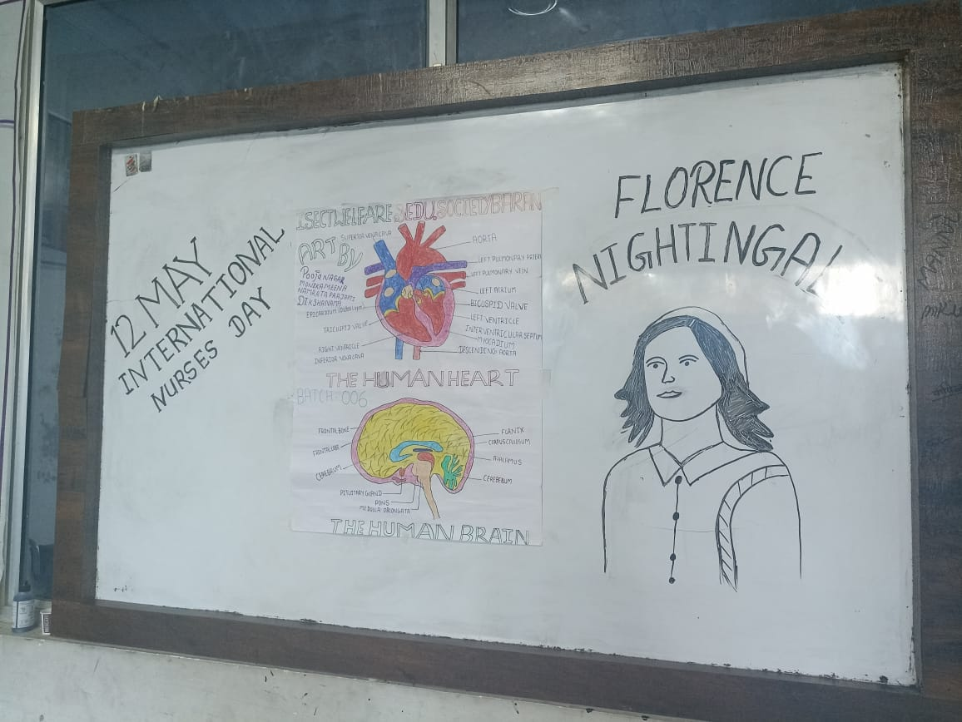

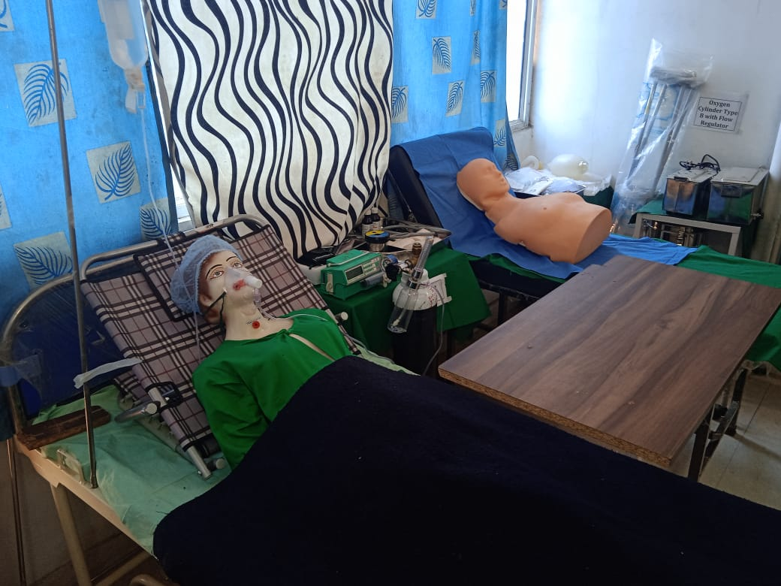

MMYKY (Mukhya Mantri Yuva Kaushal Yojna)-
This scheme aimed to skill college student while the are studying.This is a flagship scheme sponsored by the state government with the objective of injecting skills to the youth according to their interest. This programme provide an edge to nourish and identify hidden skills of a youth. There are some glimpses of this programme

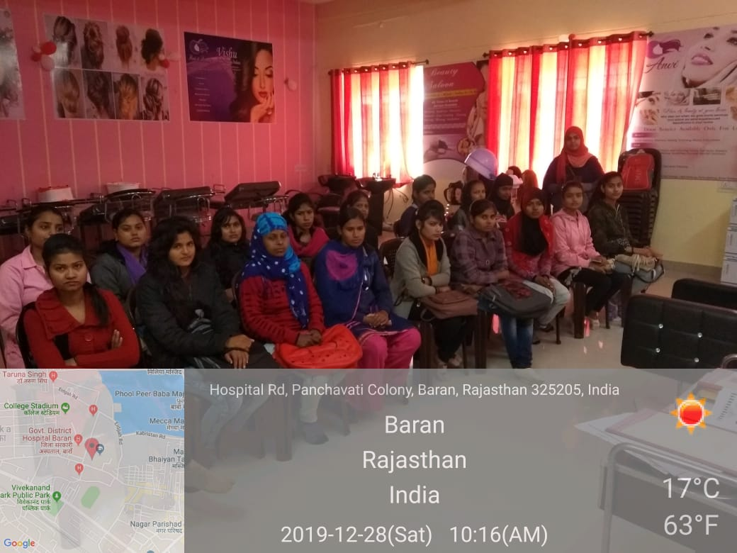

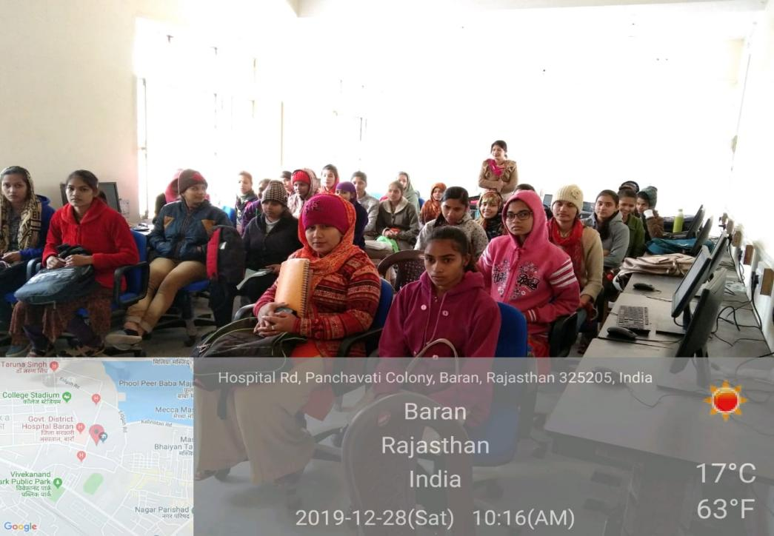

Swarojgar Aadharit Kaushal Shiksha Mahaabhiyan (SAKSHM)

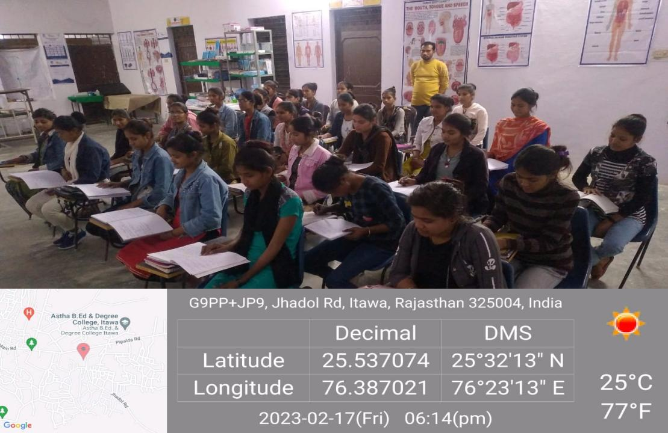

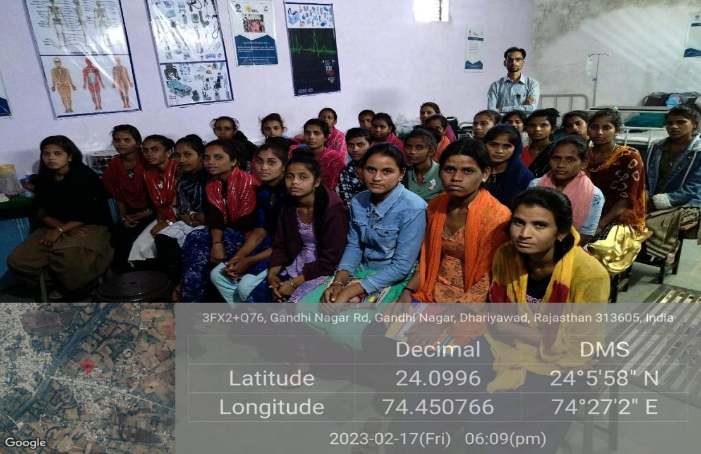

Rojgar Aadharit Jan Kaushal Vikas Karyakram (RAJKViK)

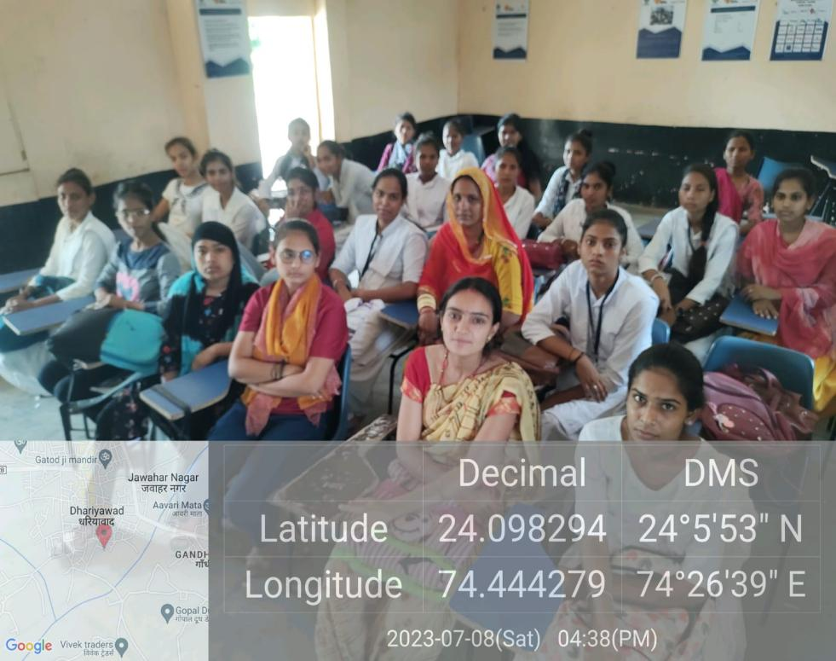

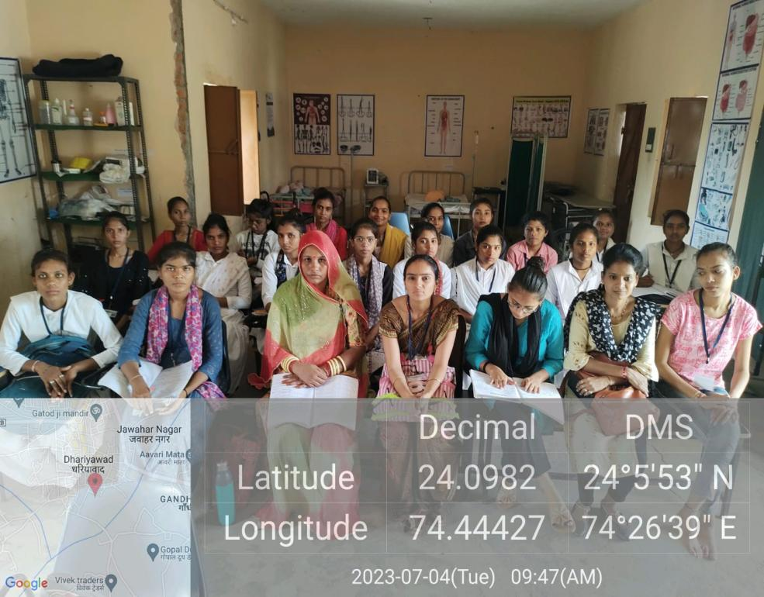

Rajasthan State Computer Information Technology (RS-CIT)

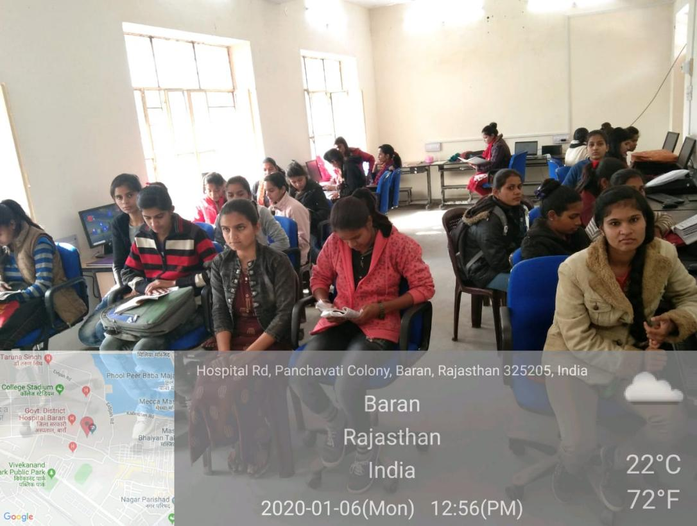

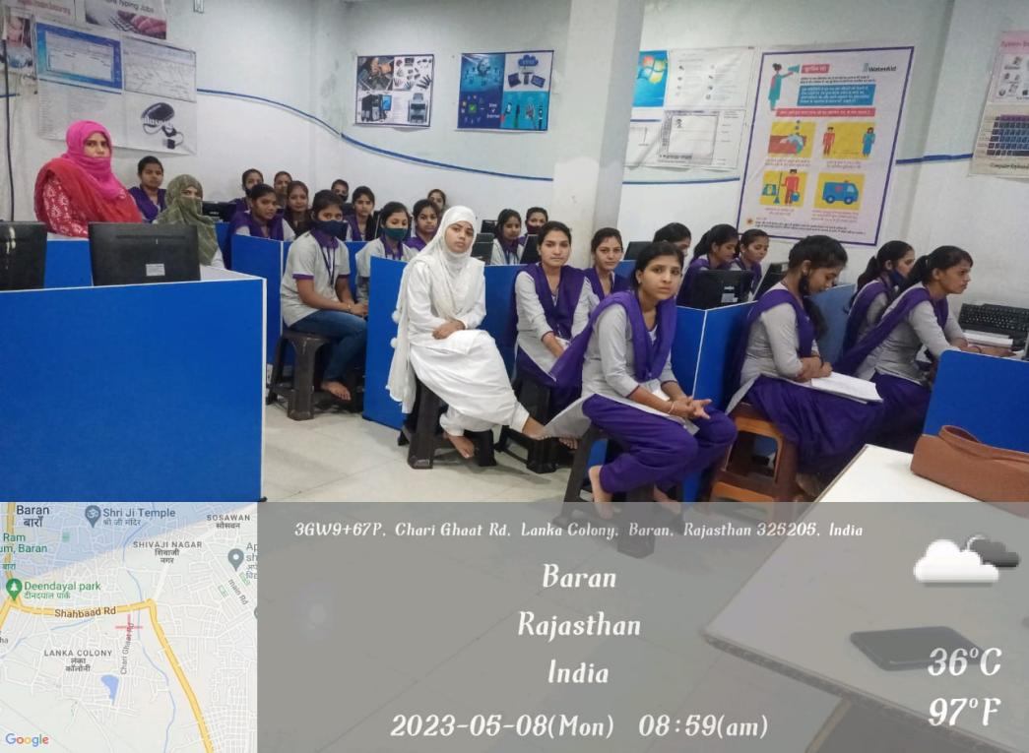

Indira Mahila- Shakti (IM-Shakti)

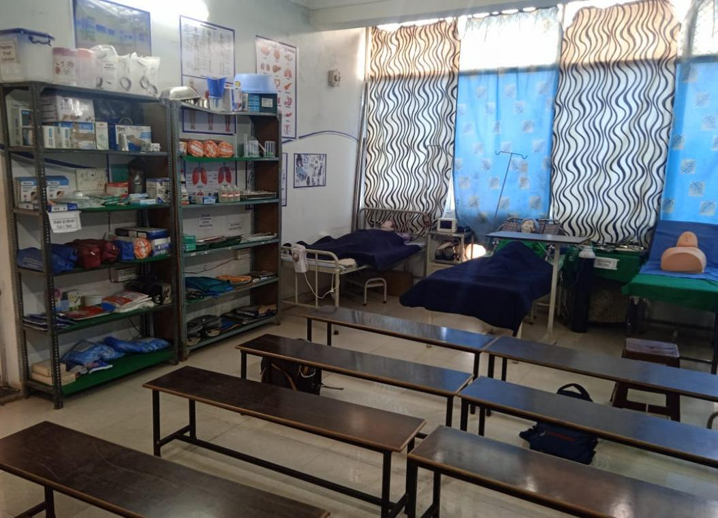

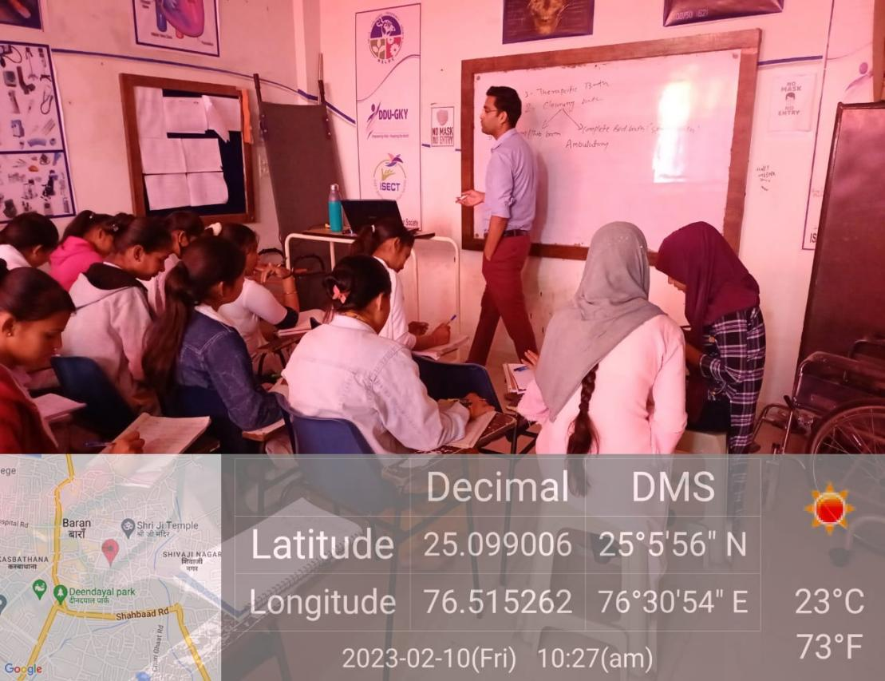

Palntation

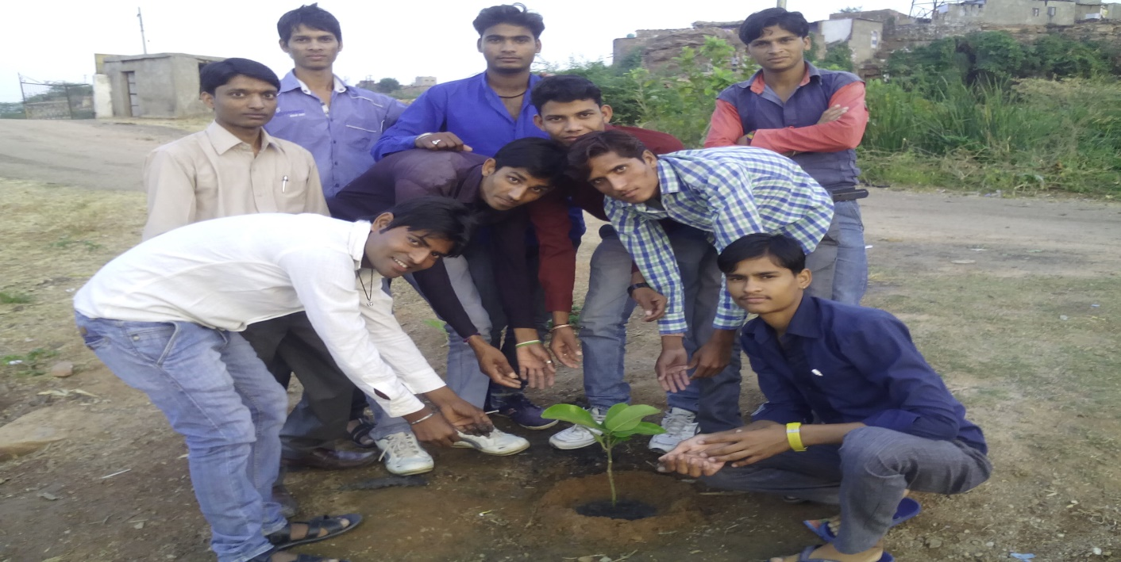

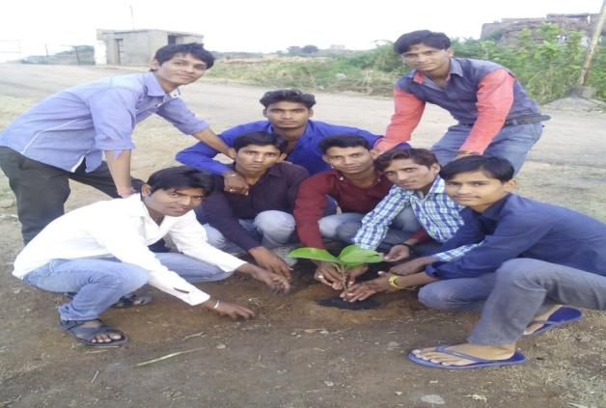
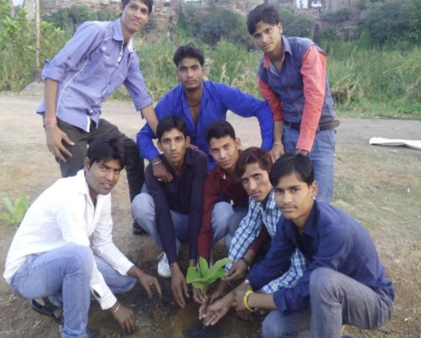

AWARENESS CAMP FOR HIV/AIDS:-
HIV/AIDS is far more than a medical problem, AIDS is far more than a national problem and AIDS is far from over” Looking the society of the problem (HIV/AIDS) whole world is shocked and continuously trying to discover the solution but still it is harming people. Even Reports are showing that people have started people of Baran distract are looting traveller showing a syringe full of HIV/AIDS virus.
The state Rajasthan is seriously affected with this harmful virus (HIV/AIDS). Looking the sensitive condition Government has decided to start is third phase “target intervention “to wipe out the problem through awareness generation among the community. The community should apply safety self.

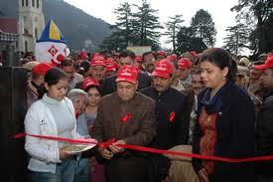

Human right Campaign:-
For the uplift of poor Deprived and marginalized community, ISECT is making efforts through right based approach by organizing campaign and participating in human right campaign to support networking organization at state and national level. Relatively, community to participate i Dalit sammelan held in Rajasthan. ISECT facilitate people to raise voice on child education through rallies, exhibition responsible government official. ISECT also facilitate community to participate in Campaign for Child education at Baran under the Rajasthan of NAFRE to increase the budget for child education.
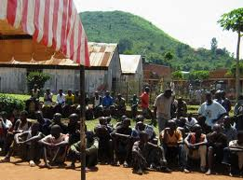

Celebration of International Women’s days:-
The purpose of this day is to recognize the fact that securing peace and social progress and the full enjoyment of human rights and fundamental freedoms require the active participation, equality and development of women; and to acknowledge the contribution of women to the strengthening of international peace and security. ISECT celebrate Women’s day in all the District.
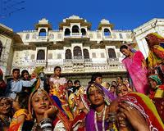

SELF HELP GROUP:-
Formation of self Help Group is one of the main factors in the process of empowering disabled persons. We never force people with disabilities or their parents to form a group but we always created opportunities for them to work as a group and gradually they became a group. We are helping the adult people with disabilities to organize themselves and work as a group for changing their socio –economic condition. At present we have formed 6 group and they are saving money in the local bank. Some groups are still in the process.
ISECT organizing training on Disability (handling situation, Acts and Rules related to Disability) for people with disability to help them to become a Resource Group of their community and actively involved in Decision Making process in the community.
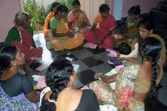

HOLI CELEBRATION
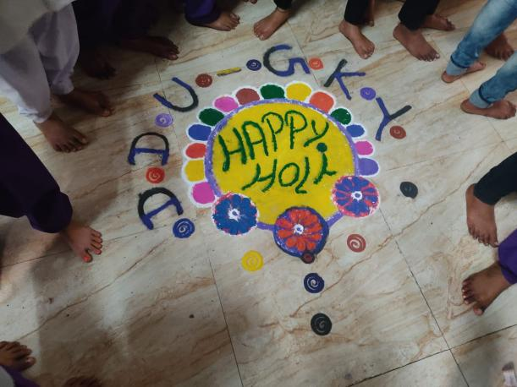
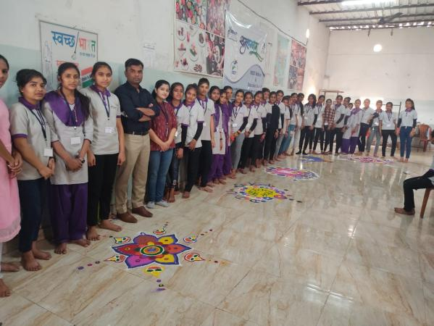

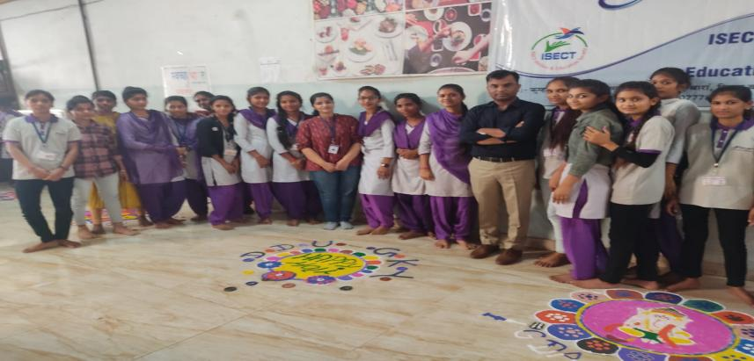

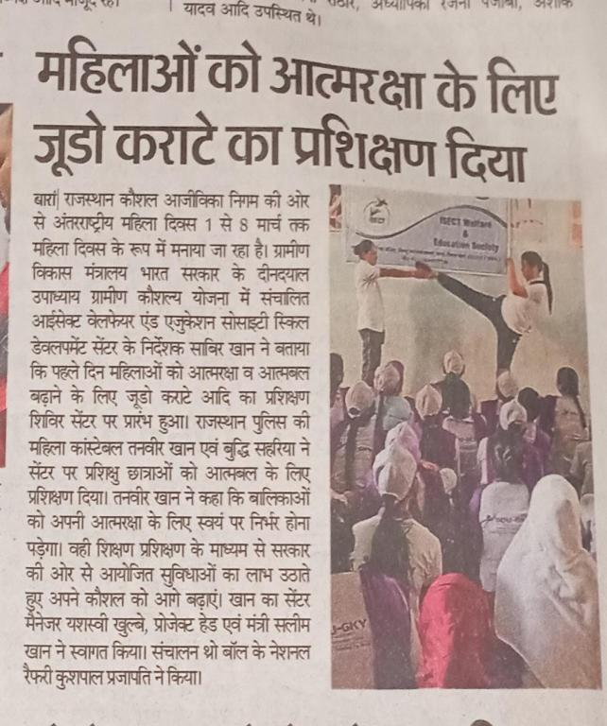
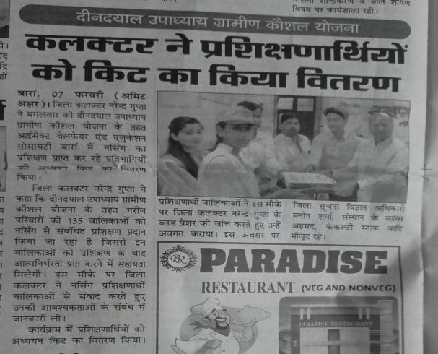
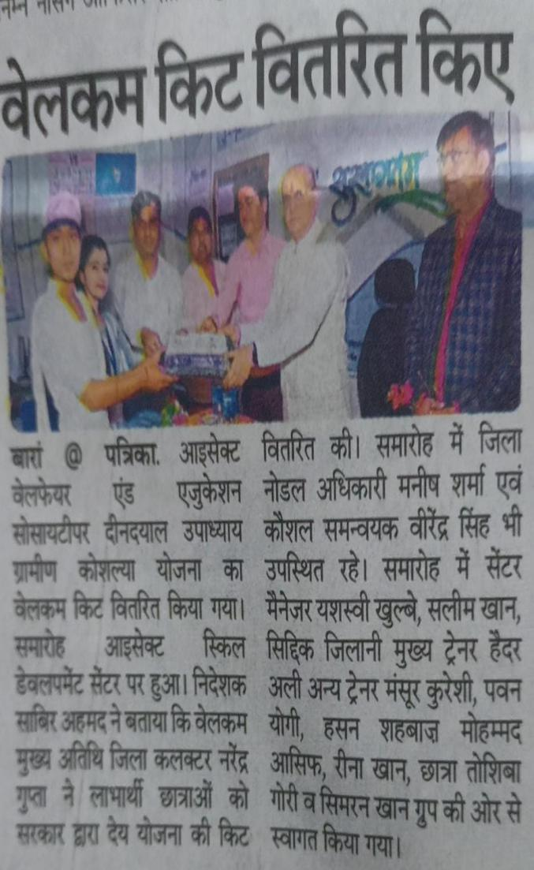
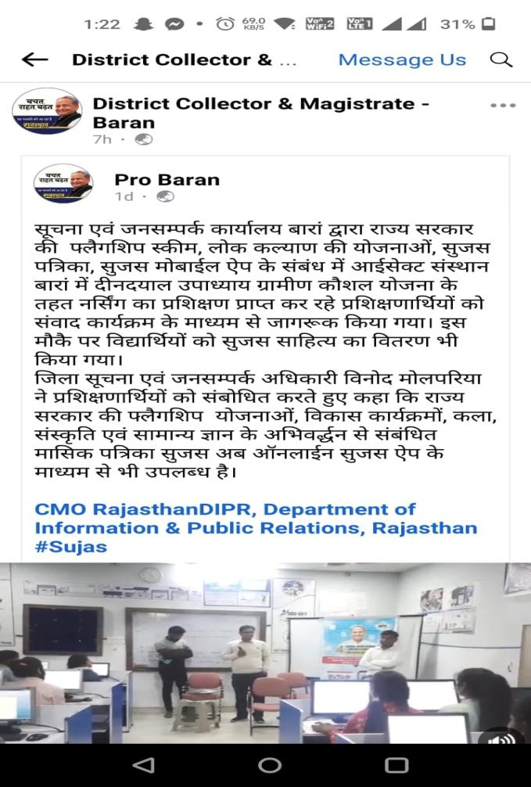
MEDIA COVERAGE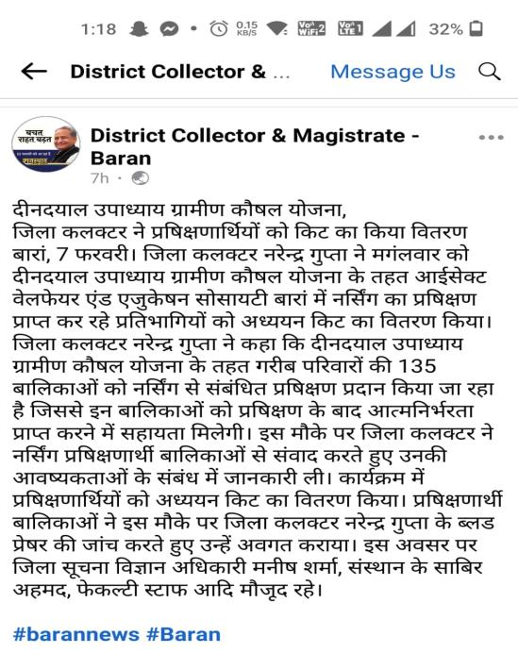

End of Annual Report
Session 2021-22

